**Improving the Beginner’s PID: Direction**

(This is the last modification in a [larger series](http://brettbeauregard.com/blog/2011/04/improving-the-beginners-pid-direction/improving-the-beginners-pid-introduction) on writing a solid PID algorithm)

**The Problem**

The processes the PID will be connected to fall into two groups: direct acting and reverse acting. All the examples I’ve shown so far have been direct acting. That is, an increase in the output causes an increase in the input. For reverse acting processes the opposite is true. In a refrigerator for example, an increase in cooling causes the temperature to go down. To make the beginner PID work with a reverse process, the signs of kp, ki, and kd all must be negative.

This isn’t a problem per se, but the user must choose the correct sign, and make sure that all the parameters have the same sign.

**The Solution**

To make the process a little simpler, I require that kp, ki, and kd all be >=0. If the user is connected to a reverse process, they specify that separately using the SetControllerDirection function. this ensures that the parameters all have the same sign, and hopefully makes things more intuitive.

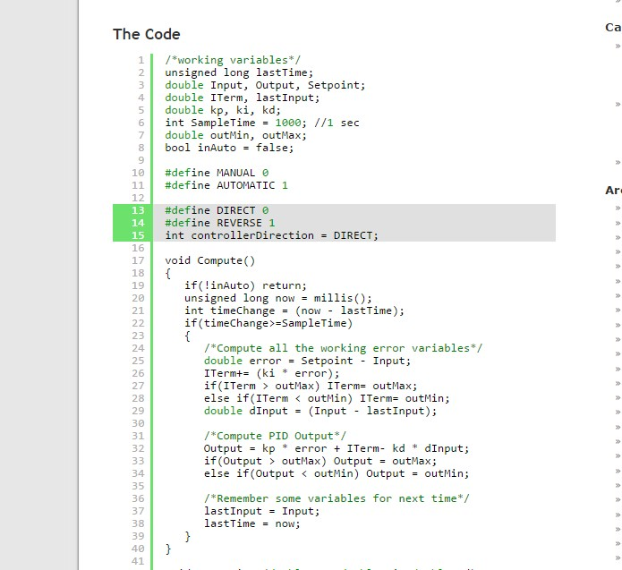

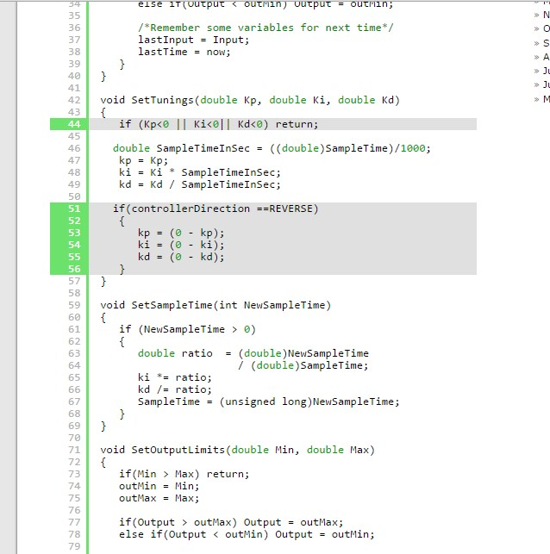

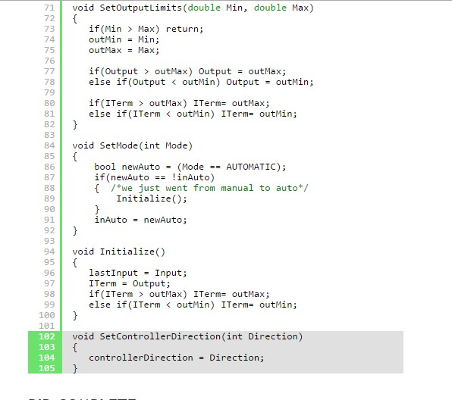

**PID COMPLETE**

And that about wraps it up. We’ve turned “The Beginner’s PID” into the most robust controller I know how to make at this time. For those readers that were looking for a detailed explanation of the PID Library, I hope you got what you came for. For those of you writing your own PID, I hope you were able to glean a few ideas that save you some cycles down the road.

Two Final Notes:

1. If something in this series looks wrong please let me know. I may have missed something, or might just need to be clearer in my explanation. Either way I’d like to know.
2. This is just a basic PID. There are many other issues that I intentionally left out in the name of simplicity. Off the top of my head: feed forward, reset tiebacks, integer math, different pid forms, using velocity instead of position. If there’s interest in having me explore these topics please let me know.